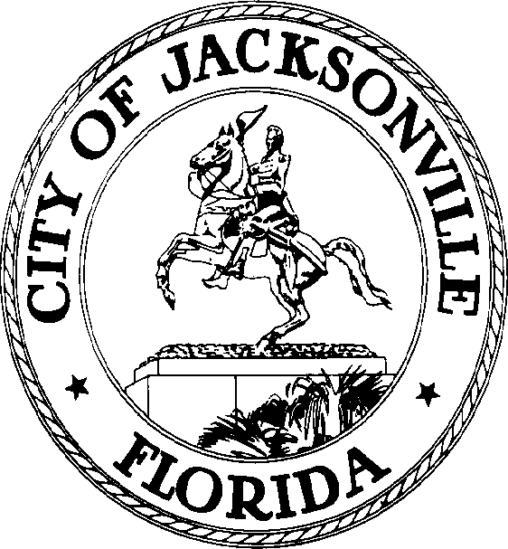

SAM C. NEWBY  Council President Group 5, At-Large  E-Mail: snewby@coj.net | OFFICE OF THE CITY COUNCIL | 117 West Duval Street City Hall, Suite 425  Jacksonville, Florida 32202  Office (904) 255-5219  Fax (904) 255-5230

April 18, 2022
2:00 P.M.
MEETING NOTICE

Notice is hereby given that the Personnel Committee will meet Tuesday, April 19, 2022 at 4:00 p.m. until adjournment, in Lynnwood Roberts, City Hall, 117 West Duval Street, 1st Floor, Jacksonville, FL 32202. The purpose of this meeting is to discuss Council Staff changes.

All interested persons are invited to attend.
For additional information, please contact Pamela Wilcox, Secretary to the President, Council Member At-Large, Group 5, (904) 255-5163.
ADA Accommodation Notice:

Pursuant to the American with Disabilities Act, accommodations for persons with disabilities are available upon request. Please allow 1-2 business days notification to process; last-minute requests will be accepted but may not be possible to fulfill. Please contact Disabled Services Division at: V 904-255-5466, TTY-904-255-5476, or email your request to KaraT@coj.net.

CC: Council Members and Staff
Margaret M. “Peggy” Sidman, Director/Council Secretary
Chief Legislative Services Division
Jeff Clements, Chief Research Division
Yvonne Mitchell, Chief Administrative Services Division
CityC@coj.net
Electronic Notice Kiosk-1st Floor City Hall
Public Notice System – City Council Web Page
Media Box
File Copy

